**Project Design Phase**

**Solution Architecture**

|  |  |
| --- | --- |
| Date | 26 June 2025 |
| Team ID | LTVIP2025TMID35580 |
| Project Name | Citizen AI – Intelligent Citizen Engagement Platform |
| Maximum Marks | 4 Marks |

**Solution Architecture:**

Our solution bridges the gap between citizens’ need for simple government information and advanced AI technology. It uses the **IBM Granite 3.3–2B Instruct** model deployed locally via a **Gradio web interface**. The architecture ensures fast response, ease of use, and offline compatibility.

**Solution Architecture Diagram:**

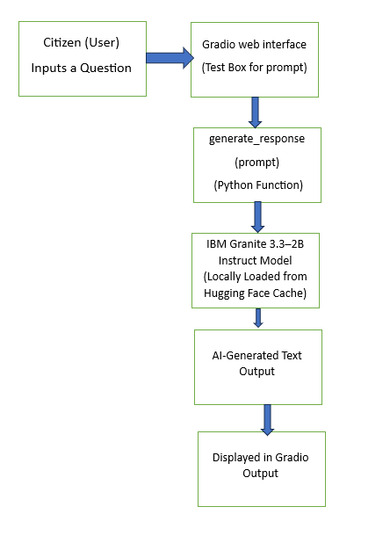

*Figure 1: Architecture and data flow*

**Key Technologies Used:**

* **Hugging Face Transformers** – To load the Granite model
* **Gradio** – For user interaction
* **Python** – Core development environment
* **Local Storage** – For model loading and reuse